# Determine Your Next Move

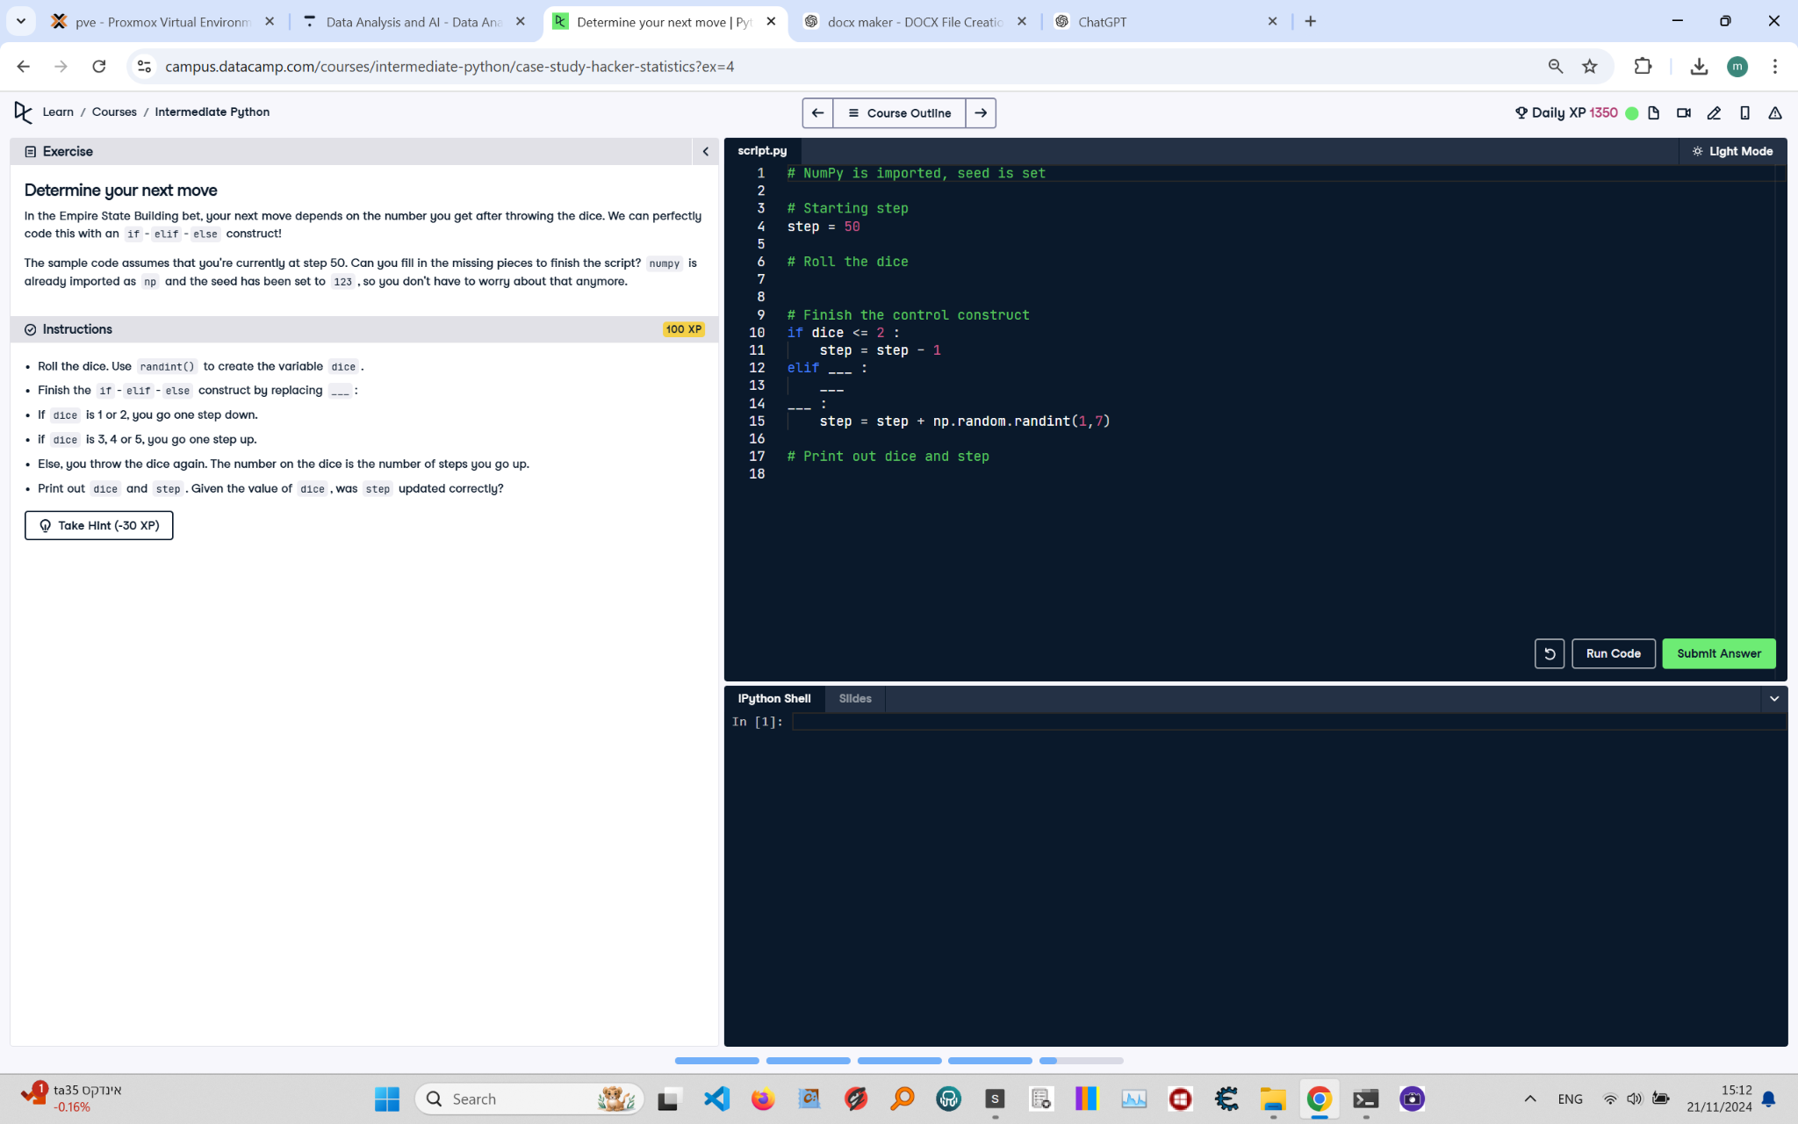

Below is the exercise on 'Determine Your Next Move' from the Python course. The image includes the instructions, code, and task details.

Solution:

# NumPy is imported, seed is set  
import numpy as np  
np.random.seed(123)  
  
# Starting step  
step = 50  
  
# Roll the dice  
dice = np.random.randint(1, 7)  
  
# Finish the control construct  
if dice <= 2:  
 step = step - 1 # Go one step down  
elif dice <= 5:  
 step = step + 1 # Go one step up  
else:  
 step = step + np.random.randint(1, 7) # Throw the dice again and add the result  
  
# Print out dice and step  
print("Dice rolled:", dice)  
print("Current step:", step)

Explanation:

1. Import numpy as np and set the random seed using np.random.seed(123) to ensure reproducibility.

2. Initialize the variable step to 50 as the starting step.

3. Roll the dice using np.random.randint(1, 7) to generate a random integer between 1 and 6.

4. Use an if-elif-else construct to determine the next step:

- If the dice roll is 1 or 2, decrease step by 1 (step = step - 1).

- If the dice roll is 3, 4, or 5, increase step by 1 (step = step + 1).

- If the dice roll is 6, roll the dice again and add the new result to step (step = step + np.random.randint(1, 7)).

5. Print out the value of dice and step to verify the calculations.